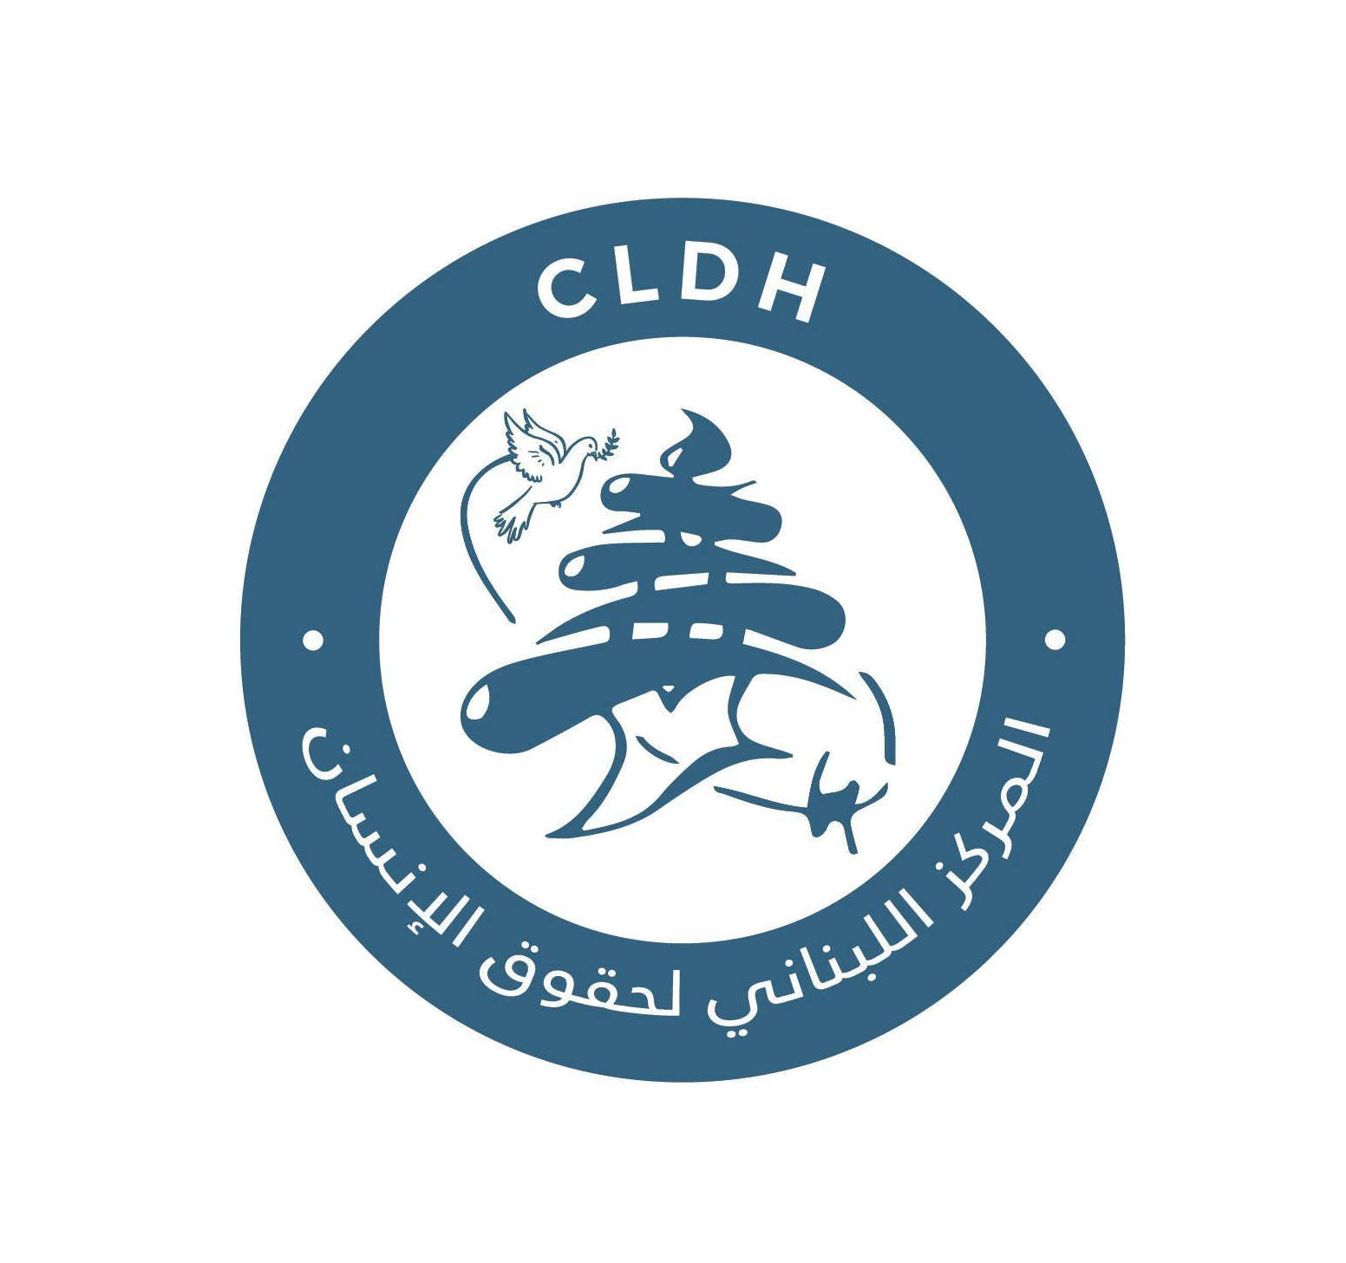
Israeli Systematic Elimination of Life: A focus on Israeli attacks on Medical and Civil Defense Centers in Lebanon between 8 October 2023 and 27 November 2024.

Policy Brief

Executive Summary
Between 8 October 2023 and 27 November 2024, the Israeli war on Lebanon was characterized by recurrent attacks on medical personnel, ambulances, hospitals, primary healthcare centers, and civil defense units. Drawing on first-hand testimonies, field documentation, and official Lebanese data, this brief presents evidence of a systematic pattern of harm to protected humanitarian services.
CLDH findings raise serious concerns of violations of International Humanitarian Law (IHL), notably the principles of distinction, proportionality, and precaution, and implicate international human rights law, including the rights to life and health.
This brief calls on the International Court of Justice (ICJ), UN agencies, and UN Member States to take urgent legal, diplomatic, and protective measures to investigate these that may amount to war crimes, uphold international law, ensure accountability, and prevent further erosion of medical neutrality.

Context & Problem Statement
Medical and civil defense services enjoy special protection under the Geneva Conventions, their Additional Protocols, and customary IHL. These protections apply unless such services are used to commit acts harmful to the enemy outside of their humanitarian function.
CLDH conducted qualitative, field-based research, including focus group discussions and key informant interviews with medical and civil defense personnel, to document incidents affecting protected services across southern Lebanon and the Bekaa. The research complements existing open-source documentation by prioritizing first-hand testimony and operational impact.

Key Findings
Israeli attacks on medical and civil defense services in Lebanon were recurrent, operationally disruptive, and psychologically deterrent, often occurring during active rescue missions and affecting clearly identifiable protected objects, including marked ambulances and known medical facilities. According to the Lebanese Ministry of Public Health, 68 attacks targeted hospitals, forcing eight to close, killing 16 people, injuring 74, and damaging 25 vehicles. In addition, 63 attacks were reported against primary healthcare centers, of which 58 were forcibly shut down. Attacks on emergency medical technicians (EMTs) reached 237 incidents, resulting in 201 deaths and 253 injuries, and causing damage to 67 centres, 177 ambulances, 59 fire trucks, and 18 rescue vehicles.
According to the WHO, 47% of attacks on healthcare in Lebanon resulted in at least one health worker or patient death, a fatality rate far exceeding the global average of 13.3% and rates in Gaza, Ukraine, and Sudan. Their cumulative impact extended beyond physical destruction, resulting in the denial of emergency medical care, forced suspension of health services, and severe psychological harm to responders. These effects constitute serious interferences with the rights to life and health under international human rights law and raise grave concerns under IHL, particularly regarding the principles of distinction, proportionality, and precaution. Under the Geneva Conventions and customary IHL, medical units and transports must be respected and protected at all times, and intentional or reckless attacks against them may amount to war crimes, engaging both the responsibility of the attacking party and the obligations of third States to ensure respect for IHL.

Obligations of the International Community
Under Common Article 1 of the Geneva Conventions, all States have an obligation to respect and ensure respect for IHL. This duty extends beyond condemnation and requires affirmative action when serious violations occur.

Recommendations
- The International Court of Justice should consider documented attacks on medical and civil defense services when assessing State responsibility and compliance with international humanitarian law and reaffirm the absolute protection of medical neutrality as well as the obligations of third States under Common Article 1 of the Geneva Conventions.
- UN agencies and relevant mechanisms should establish or support an independent international investigation into violations committed in Lebanon and strengthen systematic monitoring, documentation, and reporting on attacks against medical and civil defense services, including through coordinated reporting to relevant UN bodies to ensure sustained international scrutiny.
- Relevant UN bodies, including the General Assembly and the Human Rights Council, should be leveraged to reinforce compliance with international humanitarian law through resolutions, reporting mandates, and follow-up mechanisms, while integrating the protection of medical services across humanitarian, political, and protection-related engagement.
- UN agencies and Member States should support judicial documentation initiatives, including the preservation of evidence in line with international standards, the protection of witnesses, and the maintenance of secure chain-of-custody procedures, to ensure admissibility before international and domestic courts.
- UN Member States should employ diplomatic, legal, and economic measures to ensure respect for international humanitarian law, support accountability mechanisms including the exercise of universal jurisdiction where applicable and provide needs-based funding to restore destroyed health and civil defense infrastructure, alongside sustained psychosocial and material support for medical and civil defense personnel. States should also consider formal engagement with international judicial bodies, including the International Court of Justice, to address violations affecting protected medical and civil defense actors.
- In line with their obligations under Common Article 1 of the Geneva Conventions, UN Member States should refrain from, suspend, or terminate any form of military, financial, or political assistance to parties credibly accused of serious violations of IHL, including war crimes against medical and civil defense services, where such assistance would risk contributing to or facilitating those violations. Failure to do so engages State responsibility for aiding or assisting internationally wrongful acts.
- The Government of Lebanon should establish a national judicial documentation and investigation mechanism to systematically record, verify, and preserve evidence concerning attacks on medical facilities, ambulances, and civil defense services, pursuant to its obligations under the Geneva Conventions and the International Covenant on Civil and Political Rights, ensuring that documentation meets evidentiary standards required for future domestic and international prosecutions.
- The Government of Lebanon should ratify the Rome Statute of the International Criminal Court and accept its jurisdiction for crimes committed on Lebanese territory, thereby strengthening the domestic-international accountability nexus and enhancing legal avenues to investigate and prosecute serious violations of international humanitarian law affecting medical and civil defense services.

Conclusion
The targeting of medical and civil defense services in Lebanon constitutes a grave breach of international humanitarian protection. Failure to respond decisively risks normalizing attacks on life-saving actors and compounding civilian harm. Medical neutrality is not discretionary but a binding legal obligation on all States and institutions responsible for the maintenance of international peace and security.
Accountability for violations of international humanitarian law is equally imperative. The 2023–2024 Israeli war on Lebanon once again illustrates the consequences of impunity. International actors possess both the authority and the means to preserve evidence, ensure accountability, and uphold the integrity of the international legal order. Failure to act risks denying justice to victims and eroding the credibility of international humanitarian law itself.

“Israeli Attacks on Lebanon’s Health Sector”, Ministry of Public Health, 30 January 2025, https://www.moph.gov.lb/userfiles/files/News/30-1-2025%20Cumulative%20Report%20on%20Enemy%20Attacks/Israeli%20Attacks%20on%20Lebanon's%20Health%20Sector-compressed-english.pdf
“Lebanon: A conflict particularly destructive to healthcare”, World Health Organization, 22 November 2024, https://www.who.int/news/item/22-11-2024-lebanon--a-conflict-particularly-destructive-to-health-care

